

VET Student Handbook

TABLE OF CONTENTS

Welcome to MTC FutureReady 4
- Our Offerings 5
- Our Obligations 7
  - Legislations and Regulations 7
  - Health and Safety 8
  - Access & Equity Principles 9
  - Record Keeping, Privacy and Confidentiality 9
  - Continuous Improvement 12
  - Learner’s Satisfaction Surveys 13
- Key Enrolment Information 13
  - Eligibility criteria (Smart and Skilled) 13
  - Eligibility criteria career transition program(CTA) 14
  - Unique Student Identifier (USI) 14
  - Fees and charges 14
  - Student Transport Entitlement Concession Card 14
  - Transferring, Deferring or Withdrawing from your course 15
    - Transferring 15
    - Deferring 15
    - Withdrawing 16
- Training and Assessment 16
  - Mode of Delivery 16
  - The Trainers/Assessors 16
  - Learning Resources 17
  - Training Plans 17
  - Competency-Based Training & Assessment 18
  - National Recognition (credit transfer) 19
  - Recognition of Prior Learning (RPL) 19
  - Rules of Evidence 20
  - Assessment Submission and Record Keeping 21
    - Re-assessment 21
    - Assessment Appeal Procedure 22

- Students’ Rights and Responsibilities 24
  - Attendance 25
  - Unacceptable Behaviour 25
  - Electronic Media Usage 26
- Fees and Charges 27
  - Additional Fees and Charges 28
  - Payment Methods 28
  - Refund Policy 28
- Support Services 28
  - Reasonable Adjustments 29
  - Certificates & Statements of Attainment 30
  - Reissuing Award 31
  - Access to Records 31
  - Complaints Procedure 31
  - Additional Support Services 34
Further Information 35

ABOUT US

Welcome to MTC FutureReady
Thank you for choosing MTC FutureReady as your Registered Training Provider. MTC FutureReady is the Registered Training Organisation (RTO) of MTC FutureReady, which has been operating in the Sydney community since 1992.

What we do
MTC is the social enterprise that gives people the inspiration, capability and opportunity to create a fulfilling life. We deliver high impact employment, training and youth programs that help more than 20,000 people every year to gain skills for employment and entrepreneurship, build self-worth, and enable possibilities for transformative change. As a social enterprise, we continue to support and empower at-risk Australians, by reinvesting surplus back into innovative social impact initiatives like Warakirri College, an independent high school for students who need an alternative to mainstream education.
MTC FutureReady’ trainers, assessors and support staff will help you to maximise your
learning experience, develop your competency and achieve your learning goals.
Please read this handbook carefully as you will find a lot of useful information here. This handbook is a quick reference guide to MTC FutureReady training programs and processes and is designed to provide you with relevant information for successful completion of your training and to know your right and responsibilities as a MTC FutureReady student. You can always ask your trainer or an MTC staff member if you need more information about the program, your training or assessment.
Good luck with your study, we hope you enjoy your time with us.

Our Values
Empathy
Innovation Collaboration Achievement

Our Vision
To shape a society where everyone has the means and motivation to create a life of their choosing.

Our Offerings
MTC FutureReady offers training, assessment and qualifications throughout the Vocational Education and Training (VET) sector under the following arrangements:

- Fee for Service (FFS)
- Self-Employment Assistance (SEA)
- Skills for Education and Employment (SEE) program
- Smart and Skilled NSW Government Subsidised Training
- Fee Free Traineeships
- Career Transition Assistance Program (CTA)

All Nationally Recognised Qualifications and accredited training we offer are found on https://training.gov.au/Organisation/Details/?id=90171. Please see below for further details about each program.

BSB20120 Certificate II in Workplace Skills
BSB30120 Certificate III in Business
CHC30121 Certificate III in Early Childhood Education and Care
CHC50121 Diploma of Early Childhood Education and Care
BSB30220 Certificate III in Entrepreneurship and New Business
FSK20119 Certificate II in Skills for Work and Vocational Pathways CPCWHS1001 Prepare to work safely in the construction industry
HLTAID009 Provide cardiopulmonary resuscitation
HLTAID010 Provide basic emergency life support HLTAID011 Provide First Aid
22637VIC Course in English as Additional Language (EAL)
22471VIC Course in Initial General Education for Adults
22476VIC Certificate I in General Education for Adults (Introductory)

Fee for Service (FFS)
Fee for Service (FFS) courses are not funded, meaning that participants must pay the full course fee. The aim of this program is to offer training to suitable candidates in the qualification. Training is approved for applicants who meet the necessary pre-requisite requirements (if applicable) of the course.

Self-Employment Assistance (SEA)
MTC FutureReady’s Self-Employment Assistance (SEA) is a self-employment program, funded by the Department of Employment, that assists eligible job seekers to become self-supporting and independent from Centrelink, through the establishment and running of their own business.

SEA provides accredited small business training during participants develop their Business Plan. MTC FutureReady currently offers training in the BSB30220 Certificate III in Entrepreneurship and New Business, BSBSS00102 – Micro Business Skill Set and BSBSS00103 – New Business Ventures Skill Set. SEA is government funded; therefore, there is no cost to eligible participants.

Smart and Skilled
MTC FutureReady is an approved training provider offering government subsidised training under the NSW Government’s Smart and Skilled program. Smart and Skilled is a New South Wales (NSW) government funding incentive for those trying to gain new skills needed to find a job or advance their careers. It provides eligible students with an entitlement to government subsidised training on qualifications up to and including Certificate III level.

Fee Free Traineeships
Fee free traineeships are available to full-time employees who have been employed by a business for less than three months and part-time employees who have been employed for less than 12 months, and the training is subsidised by the NSW Government. The program will save trainees or their employers from having to pay up to $1,000 for training costs. Traineeships are a great career pathway. They combine on-the-job training with formal study to give you the skills and experience employers are looking for. Traineeships generally take around 1-2 years to complete, and trainees earn a salary while they learn.

Career Transition Assistance Program (CTA)

MTC FutureReady is an approved training provider offering a Career Transition Assistance Program (CTA) to support over 45’s on their path to employment. Our program is tailored to participant needs with a focus on individual employment goals, learning the latest digital technology and building your confidence in selling yourself to potential employers.
This program runs over the eight weeks and participants are expected to complete 75 hours of training within those periods. Upon the completion of the training, the participant will achieve Certificate of Participation award.
We’ll work with you to up-skill, learn about new industries and link you with local employers, all while participating in a collaborative, adult learning environment. With our CTA program, you have one-on-one support with your professional facilitator, every step of the way. They have extensive experience in career development and will cover a range of topics and modules to help expand your horizon and open-up new and exciting possibilities for the future.

Our Obligations

Legislation and Regulations

MTC complies with all relevant Commonwealth and state legislation and regulations. The requirements that may affect students’ rights and responsibilities include, but are not limited to:
- National Vocational Education and Training Regulator Act 2011
- Standards for Registered Training Organisation (RTOs) 2015
- Privacy Act 1988
  - Privacy Amendment (Enhancing Privacy Protection) Act 2012
- National VET Data Policy
- Freedom of Information Act 1982
- Equal Employment Opportunity (Commonwealth Authorities) Act 1987
- Human Rights and Equal Opportunity Commission (Transition Provisions and Consequential Amendments) Act 1986
  - Human Rights and equal Opportunity Commission Amendment Act 2002
- Disability Discrimination Act 1992

  - Disability Discrimination Amendment Act 2002
  - Disability Discrimination Amendment (Education Standards) Act 2005
- Work Health and Safety Act 2011 No 10 (NSW)
  - Workplace Health and Safety Regulation 2017 (NSW)
- Privacy Act 1988
  - Privacy Amendment (Enhancing Privacy Protection) Act 2012
- Freedom of Information Act 1982
- Equal Employment Opportunity (Commonwealth Authorities) Act 1987
- Training and assessment rules and conditions NSW: http://www.asqa.gov.au
- Smart and Skilled Contract Terms and Conditions
- Smart and Skilled Operating Guidelines
- CTA Panel Deed 2019-2022
- Career Transition Assistance Guideline

Health and Safety

MTC is committed to providing a safe learning environment for all participants. A risk assessment of all training facilities is undertaken annually to ensure that any potential hazards are managed.

First Aid Kits are available at all MTC sites, further medical treatment is available from the onsite First Aid Officer.

All MTC FutureReady training facilities have fire and emergency evacuation procedures which are explained to students on their first day of training. The trainer or another MTC staff member will inform you if an evacuation is required and direct you to the closest and safest emergency exit. In an emergency, please only take your closest personal belongings such as your handbag or wallet.

Should an accident or incident occur, you must report it immediately to your trainer or supervisor and complete an accident / incident report. An incident refers to an accident that could have happened (near miss); these must also be reported.
Workplace Health and Safety incident registers are located at the reception desk of all MTC campuses, or with your trainer if training is off-site.

For Career Transition participants the work health and safety (WHS) requirements will be covered in accordance with the CTA Panel Deed 2019-2022.

Access & Equity Principles

MTC FutureReady is committed to access, equity and the elimination of all forms of discrimination in its service provision. It is the policy of MTC FutureReady to create a fair and equitable learning and training environment for all participants and clients irrespective of, but not limited to: race, gender, religion, political opinion, nationality, social origin, age, medical condition (including HIV/AIDS), marital status, disability, sexual preference or trade union affiliation.

MTC FutureReady has developed processes to ensure that all MTC students, staff and contractors follow access and equity principles.

Record Keeping, Privacy and Confidentiality

MTC FutureReady retains the following records for each student:
- enrolment details and forms completed on enrolment
- attendance records
- outcomes of units of competency
- assessment evidence
- Certificates and Statements of Attainment issued
- records of appeals (if applicable)
- reasonable adjustments (if applicable)

The documents listed above are kept in hardcopy form for a period of two (2) years for SEA and three (3) years for Government Subsidised Training Smart and Skilled. An electronic record of students’ outcomes and qualifications issued is retained for a period of thirty (30) years. Should MTC close its business, all records will be handed over to another Registered Training Organisation (RTO) for safekeeping.

Student files are stored securely in locked cabinets or archived in a secure storage facility. Students’ records are entered into an online student management system called JobReady; access to this database is limited and protected by a password.

MTC FutureReady, collects, holds, uses and discloses personal information to deliver training and assessment services under the National Vocational Education and Training Regulator Act 2011. Personal information is handled in accordance with Privacy Act 1988, the Australian Privacy Principles and requirements laid down in MTC’s contracts as a service provider to the Commonwealth Government.

Your personal information (including sensitive information) is collected directly from you or from third parties. Where information is collected from a third party, you will be informed or may reasonably expect that MTC FutureReady has been given this information, will know the purpose for which it is collected, and will be able to obtain access to this information.

MTC FutureReady is required to disclose personal information (including sensitive information) to Australian Skills Quality Authority (ASQA) and, as a services provider, to the Commonwealth Government.
Disclosure of personal information to another individual/ third party, without consent, will only occur in order to lessen a serious threat to you or to public safety, and where required by law.

MTC FutureReady uses personal information (including sensitive information) for the purpose of internal audits, statistical analysis, AVETMISS reporting (please see more information below), research and program evaluations.

MTC FutureReady is required by law to report certain information about its students, such as their employment status, prior education and citizenship status. This information is collected from the Enrolment Form that each student completes (AVETMISS questions). Data about students is submitted to the National Centre for Vocational Education Research (NCVER). Details of the NCVER privacy policy can be found on their web site at www.ncver.edu.au.

MTC FutureReady Privacy Notice

Why we collect your personal information
As a registered training organisation (RTO), we collect your personal information so we can process and manage your enrolment in a vocational education and training (VET) course with us.

How we use your personal information
We use your personal information to enable us to deliver VET courses to you, and otherwise, as needed, to comply with our obligations as an RTO.

How we disclose your personal information
We are required by law (under the National Vocational Education and Training Regulator Act 2011 (Cth) (NVETR Act)) to disclose the personal information we collect about you to the National VET Data Collection kept by the National Centre for Vocational Education Research Ltd (NCVER). The NCVER is responsible for collecting, managing, analysing and communicating research and statistics about the Australian VET sector. We are also authorised by law (under the NVETR Act) to disclose your personal information to the relevant state or territory training authority.

How the NCVER and other bodies handle your personal information
The NCVER will collect, hold, use and disclose your personal information in accordance with the law, including the Privacy Act 1988 (Cth) (Privacy Act) and the NVETR Act. Your personal information may be used and disclosed by NCVER for purposes that include populating authenticated VET transcripts; administration of VET; facilitation of statistics and research relating to education, including surveys and data linkage; and understanding the VET market.
The NCVER is authorised to disclose information to the Australian Government Department of Education, Skills and Employment (DESE), Commonwealth authorities, State and Territory authorities (other than registered training organisations) that deal with matters relating to VET and VET regulators for the purposes of those bodies, including to enable:
- administration of VET, including program administration, regulation, monitoring and evaluation

- facilitation of statistics and research relating to education, including surveys and data linkage
- understanding how the VET market operates, for policy, workforce planning and consumer information.
The NCVER may also disclose personal information to persons engaged by NCVER to conduct research on NCVER’s behalf. The NCVER does not intend to disclose your personal information to any overseas recipients. For more information about how the NCVER will handle your personal information please refer to the NCVER’s Privacy Policy at www.ncver.edu.au/privacy.
If you would like to seek access to or correct your information, in the first instance, please contact your RTO using the contact details listed below. DESE is authorised by law, including the Privacy Act and the NVETR Act, to collect, use and disclose your personal information to fulfil specified functions and activities. For more information about how the DESE will handle your personal information, please refer to the DESE VET Privacy Notice at; https://www.dese.gov.au/national-vet-data/vet-privacy- notice.

Surveys
You may receive a student survey which may be run by a government department or an NCVER employee, agent, third-party contractor or another authorised agency. Please note you may opt out of the survey at the time of being contacted.

Contact information
At any time, you may contact MTC FutureReady to:
- request access to your personal information
- correct your personal information
- make a complaint about how your personal information has been handled
- ask a question about this Privacy Notice
- MTC FutureReady Customer Care Support phone number: 1300 232 663
- MTC Privacy Policy; https://www.mtcfutureready.org.au/privacy-at-mtc-futureready/

Continuous Improvement

MTC FutureReady is committed to continual enhancement of its operations so that the changing needs of clients and industry continue to be met. We systematically monitor our training and assessment strategies and making sure it meets the quality.
We encourage all students to provide feedback about the quality of training, learning and facilities and resources. All verbal and written feedback can be provided throughout your training. We are always keen to hearing about our service and your training experience with MTC FutureReady.

Learner Satisfaction Surveys

MTC FutureReady conducts regular learner satisfaction surveys to monitor its quality of service. Student feedback is highly valued as it helps MTC to develop and improve program management processes, and delivery of training and assessment.
Furthermore, MTC FutureReady uses the feedback collected from students to report to the Registering Body (Australian Skills Quality Authority) on its performance.
Completing the questionnaire is voluntary and students remain anonymous; individual respondents are not identified in any data or reports.

Key Enrolment Information

Eligibility criteria (Smart and Skilled)

You may be eligible to enrol in the government subsidised training Smart and Skilled if you:
- are aged 15 years or older
- live or work in NSW
- are no longer in secondary education
- are an Australian citizen, permanent resident, humanitarian visa holder or New Zealand citizen
You can check your eligibility for Smart and Skilled training at https://smartandskilled.nsw.gov.au/are-you-eligible

Eligibility criteria career transition program (CTA)

All job seekers aged 45 years and over who are registered with a jobactive Provider are eligible to participate in CTA.

Unique Student Identifier (USI)

From 1 January 2015 onwards, all students who undertake vocational education and training must hold a unique student identifier (USI). A Unique Student Identifier (USI) number is a unique reference number made of 10 numbers that is allocated to anyone studying nationally recognised Vocational Educational Training (VET) in Australia. This can be obtained by registering online at http://www.usi.gov.au.

Fees and charges

Government subsided training in NSW is called ‘Smart and Skilled’. Under Smart and Skilled fees are determined on eligibility as listed above in 2.1. You can get an estimate of the fee for your preferred course in the course finder: https://smartandskilled.nsw.gov.au/sands/find-a-course.
Further information about MTC FutureReady’s Fees policy and procedures are covered in
Clause: Fees and Charges (6.1 – 6.3) of this Student Handbook.

Student Transport Entitlement Concession Card:

MTC FutureReady is registered with the Transport for NSW (TfNSW) to ensure its students are provided opportunities of seeking subsidised travel concessions on public transport services subject to meeting the eligibility criteria.
MTC FutureReady informs every student about the availability of Student Transport Entitlement Concession cards as part of their enrolment process. At this stage, each student must be provided information about:
- transport concessions benefit available to eligible recipients
- the eligibility criteria for getting the concession benefits
- the process of applying for the concession subject to meeting the eligibility criteria
The process of assessing a student’s eligibility criteria has been detailed in the
Transport NSW
Guidelines for Issuing NSW Tertiary Student Concessions.
Please contact MTC FutureReady for more details

Transferring, Deferring or Withdrawing from your course

Transferring

Transferring from other provider to MTC FutureReady

If you are enrolled with other training provider in a qualification funded under NSW Smart and Skilled, you may withdraw from that qualification from them and transfer to MTC FutureReady. Depending on the reason for the transfer, your fees payable may change. MTC FutureReady will advise you of any changes to your fees. In such cases, admission is processed as per our enrolment process.

Transferring from MTC FutureReady to other provider

If you are enrolled with us in a qualification funded under NSW Smart and Skilled, you may withdraw from the qualification and transfer to another Smart and Skilled Training Provider. In such cases, you will need to complete the Withdrawal/Refund/Deferment Request Form (available on MTC website) and present with requested information. Depending on the reason for the transfer, the fees you pay may change. Your new Provider should be able to calculate any changes to your fees and update you.

Deferring

If you are enrolled with MTC FutureReady in a qualification offered under the Subsidised Training and experiencing difficulties with your training due to personal or other related circumstances; you may wish to defer your studies for a maximum period of 12 months from the date of written request. If you choose to defer your studies, you are required to complete a Withdrawal/Refund/Deferment Request Form (available on MTC website). There are fee implications of deferring subsidised training; MTC FutureReady will advise you of these fees at the time of deferment.
MTC FutureReady will extend full support to ensure you are able to continue and complete your studies.
It is essential that you recommence your training within the 12 months period from the date of commencement of your deferment period. If you fail to do so, we have an obligation to advise the NSW Department of Education and Communities about your decision to discontinue the subsidised training.

Withdrawing

A student may withdraw/discontinue from a course for any reason. Should you require cancelling or withdrawing from your training at any time, you must advise MTC FutureReady in writing by completing the Withdrawal/Refund/Deferment Request Form (available on MTC website).
For more details about receiving a refund, please refer to the Refund Policy in this handbook. If a student has successfully completed at least one module or unit of competency, he/she may be eligible for a Statement of Attainment.

Training and Assessment

Mode of Delivery
MTC FutureReady delivers courses through classroom-based mode. Students are provided with the necessary training, assessment and reference materials for each unit of competency. Assessment tasks may be conducted in class, in a simulated workplace, or on-the-job based on the requirements of the qualification. MTC FutureReady assessment tools are customised to meet the needs of their clients.
Career Transition Program (CTA): This course delivers face to face Full time/Part time with a total number of 15 participants per group with a maximum of 25 hrs per week.

The Trainers/Assessors
MTC FutureReady employs qualified trainers/assessors who are industry/subject matter experts and are capable of delivering high quality of training to all students. All trainers/assessors have an obligation to maintain currency of their knowledge and skills annually to continue delivering training and assessment activities of our students.
Career Transition Program (CTA): sessions are based on an interactive and collaborative approach by our qualified professional Facilitator who will encourage students to share their ideas and will support students throughout the course.

Learning Resources
MTC students are provided dedicated learning resources on commencement of their training. These resources are specifically designed to ensure our students get a proper understanding of the subject, and assist in completion of the required assessment tasks.

Training Plans
MTC FutureReady provides a structured Training Plan to all enrolled students for any qualification offered under the government subsidized Smart and Skilled training. This will be provided at the commencement of your training.
A training plan outlines the training requirements and includes the following, but not limited to
- details of the Units of Competency to be completed
- the timeframe for achieving each unit of competency including start date and end date of each UOC
- mode of training delivery for each Unit of Competency
- method of assessment for each Unit of Competency
Training plans can be customised to meet your requirements. Please contact your trainer for any assistance regarding the plan.
Career Transition Program (CTA): The content of each CTA course includes the core components which are listed below
- Career Pathway Assessment
- Develop Goals and Motivations
- Understand the Local Job Market and Identify Suitable Opportunities
- Explore and Translate Transferable Skills
- Improve and Tailor Resumes
- Navigate the Job Application Process
- Practise and Enhance Interview Skills
- Functional Digital Literacy
- Experience Different Industries
- Current Information Technology and Media devices and equipment
- Prepare a Career Pathway Plan
MTC FutureReady assists ongoing additional support to each participant that may also be required to meet their individual needs.

Competency-Based Training & Assessment
Competency-based training develops the skills, knowledge and attitudes required to achieve competency standards. AT MTC FutureReady, assessments are competency- based assessments. Competency-based assessment is:
- criterion based, meaning the student is not assessed in competition with others, but against a set criteria or benchmark,
- evidence based, meaning the decision of whether a student is competent is based on the evidence they provide to the assessor, and
- participatory, meaning the student is involved in the process of assessment and has the opportunity to negotiate with the assessor the form the assessment activities will take.

For each assessment that is undertaken, a student may receive either a Competent or Not Yet Competent result. In order to be assessed as Competent (C), the student must provide evidence that demonstrates his/her ability to perform the required competencies to the required standard. If a student is deemed Not Yet Competent, he/she has the opportunity to resubmit or re-sit the assessment.

Students are assessed through a range of activities which may include:
- Assignments
- Documented observations
- Completed workbooks
- Presentations of workplace documents, for example diaries, journals and reports
- Simulations or role plays
- Interviews
- Presentations
- Interviews with supervisors and/or employers

National Recognition (credit transfer)
MTC FutureReady is obligated to acknowledge all nationally recognised qualifications issued by other Registered Training Organisations (RTOs). MTC may need to verify a candidate’s qualification/s in the event that the course that she/he would like to enroll in requires pre-requisite units, or if the student would like to apply for a credit transfer. In order to verify a qualification, MTC FutureReady will check that the issuing RTO exists and that they have the relevant qualification on their scope of registration. If the verification of authenticity cannot be confirmed, MTC may contact the issuing RTO to confirm the candidate’s enrolment and award.

A Credit Transfer (CT) is a form of national recognition that allows a student to receive credit for study he/she has previously undertaken. Students who wish to apply for a credit transfer must hold a Certificate or Statement of Attainment that list one or more units of competency from the same training package that MTC delivers. MTC FutureReady will inform you if your application for a credit transfer has been granted.

Note: Fill out a Credit Transfer Application form and submit it to MTC FutureReady together with a verified copy of your Certificate of Statement of Attainment.

Recognition of Prior Learning (RPL)
Recognition of prior learning (RPL) is a process that assesses your competency, acquired through formal and informal learning, to determine if you meet the requirements for a unit of study. We recognise the prior knowledge and skills students may have gained through previous training, education or work, including formal and informal learning. Candidates suitable for RPL must have experience in life and/or work relevant to the chosen competency and be able to support this through documented evidence. Students can complete a course in full or partially through RPL.

Please contact MTC FutureReady on 1300 232 663 for further information about RPL.

Rules of Evidence
The assessor must ensure that the evidence is valid, current, sufficient and authentic. These are referred to as the ‘Rules of Evidence’ and have been defined below:

Validity
The evidence collected/gathered by the student must be relevant and from a reliable source. In order to determine relevance and reliability, the evidence must meet two assessment requirements.
- Unit of competency performance criteria; and
- Specific evidence requirements, both of these criteria are found in each unit of competency, within the relevant raining package.

Currency
The evidence collected/gathered by the student must have been completed (if a certificate or previous training or letter of such a course) or documented (if a workplace report, memo, policy, procedure or other thing carried out or actioned, by the student) within the last 6 months).

The objective here is to provide or demonstrate something, which if carried out now, would resemble that which was provided or demonstrated, previously. The question is…Can the student still do now, exactly, as they did previously?

Currency is very subjective, and timelines may differ, dependent upon the type of competency or criteria being demonstrated or document submitted.

Sufficiency
The evidence collected/gathered by the student must be sufficient, that is, there must be an adequate amount of evidence submitted. Specific requirements are in line with the evidence requirements for each unit within the relevant training package. This advises the student and assessor the minimum evidence requirements needed to be collected or demonstrated.

Authenticity
The evidence collected/gathered by the student must be authentic. That is, the evidence must not be forged, untrue or misleading. For example – any previous certificate or testamur will need to be certified as a copy, by a JP or an original tendered. Reports, assessments completed, or anything created by the student, must be declared as the work of the student. Third party reports/observer reports may also be required, in replace of, or in addition to, a student’s declaration.

Assessment Submission and Record Keeping
The trainer will inform all students of the assessment schedule. Students are required to submit all assessment tasks on time and attend planned assessment sessions.
Assessment evidence must be the student’s original work.
Where you may have used some information from a source, referencing is required to acknowledge information from the source/sources where you have used their information in your assessment. If you fail to reference another person’s ideas, theories or data you will be in breach of copyright or may be accused of plagiarism. Any work found to be copied from another student, or taken from a source without reference, will be deemed Not Yet Competent.
MTC FutureReady retains a record of all units of competency achieved by a student for a period of 30 years.

Re-assessment

Some students are unable to meet the assessment requirements in the first attempt. MTC FutureReady understands such situation and is committed to assist all of its students in further development of their knowledge and skills with an aim to their successful completion of the assessment tasks. In such instances, we encourage you to speak to your assessors for rearranging your assessment schedules to ensure you are able to complete your qualification on time. MTC permits two (2) assessment resubmissions per unit of competency; any additional attempts must be justified and may incur a fee.

Assessment Appeal Procedure
Upon completion of your assessments, your Trainer/Assessor will inform you of the assessment outcome and provide you with feedback on your performance. You have the right to appeal an assessment decision if you feel that it was wrong or unfair. In such instances, you can lodge an appeal in writing within ten (10) days of receiving your result. MTC will endeavour to have the work re-marked by a different trainer within 2 weeks of the appeal application.
MTC FutureReady takes all assessment appeals seriously and handles them in a timely, professional and confidential manner. For more information about the assessment appeals process, please see the flowchart below. If you are satisfied with the result
at any stage of the process, the appeal will end, and you do not have to do anything else. MTC FutureReady has Assessment Appeal Procedure available on MTC FutureReady Website ET SOP 046 Assessment Appeal Procedure

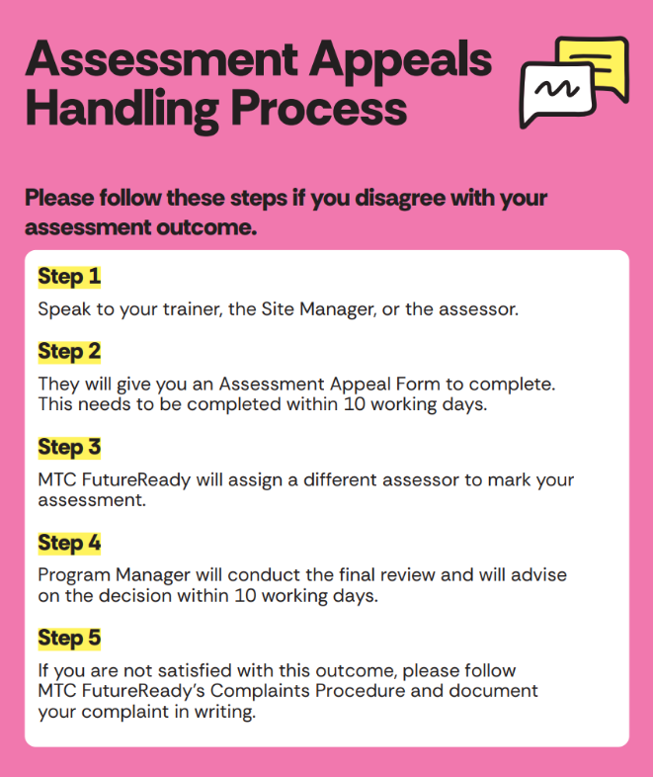

You can also download the Assessment Appeal Form online

Students’ Rights and Responsibilities

MTC students have the right to:
- receive efficient and courteous service
- expect truth in advertising
- be provided with accurate charges without any hidden costs
- be treated with respect
- access the service without discrimination
- be protected from all forms of harassment
- have their privacy respected and confidentiality maintained in accordance with the privacy policy
- be provided with adequate information to be able to make decisions about the service delivery
- know about policies and legislations relevant to them
- provide comment and feedback and have it acted upon where it will improve the service
- provide input to the management of the service, as appropriate
- be provided with information on how to lodge a complaint, grievance or appeal against the service
- pursue any complaint, grievance or appeal about the service without retribution
- an advocate of their choice
- a learning environment, which is conducive to effective learning
- quality delivery of courses that recognise and appreciate individual needs and learning styles
- Submit a complaint if they feel that the services agreed to have not been delivered.
- Any changes to the training product and or delivery will be communicated in a timely manner.

MTC students have the responsibility to:
- be punctual
- respect the property of MTC
- treat staff and other participants with respect and courtesy
- refrain from swearing and offensive language and topics that may offend others
- not behave in any way that could offend, embarrass or threaten others
- not to use mobile phones, mp3 players or similar devices at any time during training
- keep staff informed of any changes, which may affect the service being provided
- provide accurate information about themselves and advise of any changes
- participate in decisions made in regard to service delivery
- provide comments and feedback regarding the service
- discuss any concerns or difficulties with staff
- not engage in plagiarism, collusion or cheating in any assessment task
- submit all assessment tasks by the due date or ask for an extension if there are exceptional circumstances
- follow standard safety practices (e.g., following both written and verbal directions given by staff)

Attendance

MTC FutureReady requires the student to:
- be on time for all training sessions
- explain any absences to the trainer and, where asked, provide appropriate requested evidence (e.g. medical certificate)
- catch up on any work missed due to an absence or lateness

Students who continue to miss class and are not making progress in the course may be withdrawn without the right to apply for a refund (if applicable).
Career Transition Program (CTA): MTC FutureReady keep each participant’s attendance record in the Department’s IT systems in accordance with CTA Panel Deed 2019-2022

Unacceptable Behaviour

MTC FutureReady does not accept poor behaviour within our training facilities. The following behaviour will not be tolerated under any circumstances:
- verbal or physical abuse of trainers, MTC staff or other participants
- destruction or damage to information or property
- disruption to courses, training or assessment
- theft of resources or equipment
- behaviour which risks the health and safety of themselves or others
- offensive language (swearing) or discussion of topics that may offend
- possessing, consuming or being under the influence of alcohol or illegal drugs or substances
- wearing clothing which may be offensive to others
- smoking in the building and near the main entrance of the building
- eating in the classroom

Failure to comply with any of the behaviour listed above, or other serious behaviour breaches, may result in disciplinary action, including the student being withdrawn from the course.

Electronic Media Usage

Internet, e-mail and other electronic systems are provided by MTC FutureReady to assist students in the delivery of their training. These resources are not for personal use or for the entertainment of individuals. Students must not:
- originate or circulate mail items with offensive content
- use abusive, offensive or defamatory language in messages
- use electronic communications to harass, defame, abuse other participants, staff or others
- place unlawful information on the system or individual devices
- send messages that are likely to result in the loss of the recipient’s work or
systems
- send or participate in the circulation of chain letters or unauthorised broadcast messages
- send offensive material, including material which contains sexual innuendo, references or material that denigrates or vilifies a particular group or individual
- access sexually orientated, pornographic or otherwise offensive sites, including gambling
- solicit sexually orientated, pornographic or otherwise offensive material from external sources
- cause congestion of the network or interfere with the work of others
- use the electronic facilities in a manner that may give rise to breaches of legislation on sexual harassment, racial discrimination, disability discrimination or other anti-discrimination legislation
- violate any software licences, copyrights, state, federal or internal laws or regulations governing intellectual property and on-line activities

Failure to comply with any of the responsibilities listed above, or other serious behaviour breaches, may result in disciplinary action, including the student being withdrawn from the course.

Fees and Charges
The Fee amount usually consists of the:
- enrolment fee
- administration fee
- tuition fee
- course materials
- handling charge (if applicable)

Under Smart and Skilled program the fee charge for enrolled students will be based on the Smart and Skilled provider calculator. Please refer to MTC FutureReady ET SOP 019 Collecting and Protecting Fees Procedure available on our website for details of all applicable fees and charges.

The Administration fee (enrolment fee) is paid before or on commencement of the course. MTC FutureReady reserves its rights to refuse commencement of training for students who fail to pay their fees.
The total course fee can be paid in full or through regular instalments. Please contact MTC FutureReady to discuss a payment plan.

Students are required to finalise all course fee payments by the completion of training. MTC FutureReady will not release a Certificate or Statement of Attainment to a student who has not paid the full course fee.

Additional Fees and Charges
Additional fees and charges applicable:
- $30: for credential request, such as a re-issue of either a qualification, transcript of results, or certificate of participation.
- assessment re-submission, for 3rd submission and above.

Payment Methods
Fees and charges can be paid via EFTPOS and Bpay. Cash payments are not accepted.
- An EFTPOS terminal is available at MTC site. Please approach the reception desk to process your payment; you will need to provide proof of identity.
- For BPay transactions please follow the instructions available at the bottom of the Tax Invoice.

Refund Policy
A refund of all or part of the paid fee may be given under special circumstances. For more details about receiving a refund, please refer to P 053 Refund Policy on our website.

Support Services
If you have a problem relating to your training or assessments, please speak to your trainer or contact MTC FutureReady. Please ask your trainer or an MTC FutureReady staff member if you require a copy of a form. Forms that you may need include:
- Reasonable Adjustment Form (A)
- Reasonable Adjustment Form (B)
- Change of Details Form
- Access to Records Request
- Withdrawal / Refund/Deferment/Transferring Request Form
- Credential Request
- Assessment Appeal Form
- Complaints Form
- Credit Transfer Application
Career Transition Program (CTA): MTC FutureReady assists ongoing support to each participant who completes a CTA course in accordance with CTA Panel Deed 2019- 2022 and participants Career Pathway Plan.
Within five working days of completion of CTA Course, we arrange a face to face Warm Handover meeting between participant, CTA Facilitator and Job active provider to discuss the next steps for pursuing participant employment opportunities or work experience opportunities.

Reasonable Adjustments
An adjustment is a measure or action taken to assist a student who has a disability, or language, literacy or numeracy issues, in order to participate in education and training on the same basis as other students. If you feel that you have a special need and may require an adjustment to participate in training or assessment, please apply for a reasonable adjustment. MTC FutureReady will implement adjustments that are deemed necessary and reasonable. Please refer to ET SOP 018 Providing reasonable adjustment procedure for further details available on our website.

In assessing whether a particular adjustment is reasonable, MTC FutureReady will consider:
- the student’s disability and his/her views regarding their needs
- the effect of the adjustment on the student, including the effect on his/her ability to: achieve learning outcomes, participate in the course/program, or act independently
- the effect of the proposed adjustment on anyone else affected, including the education provider, staff and other students
- the costs and benefits of making the adjustment

MTC will notify you of the application decision prior to the commencement of training or assessment.

Note: Fill out a Reasonable Adjustment Form (A) and submit to MTC FutureReady.

Certificates & Statements of Attainment

MTC FutureReady issues a Certificate or Statement of Attainment to all participants who have been assessed as competent in accordance with the requirements of the qualification.

A Certificate certifies that the student has successfully completed all units of competency (and work placement, if applicable) to achieve the full qualification. A Statement of Attainment certifies that the student has completed one or more units of competency (and work placement, if applicable) but has not achieved the full qualification. MTC FutureReady complies with the Standards for Registered Training Organisations 2015 and the Australian Qualifications Framework (AQF), when issuing qualifications and statements of attainment. All qualifications issued by MTC FutureReady are nationally recognised.

A Certificate or Statement of Attainment contains:
- the full name of the person receiving the award
- the national code and full title of the qualification achieved
- the national code and full title of the units of competency achieved
- the date the qualification was issued
- a unique document identification number
- the Nationally Recognised Training logo
- MTC logo, RTO code and contact details

MTC FutureReady issues a Certificate or Statement of Attainment within 30 days of the students’ completion or withdrawn dates. Issued qualifications can be collected in person from an MTC site or emailed to the student.

MTC FutureReady will not release a qualification if the student has
- not completed all assessments successfully
- not paid all course and any related fees
- not provided a valid USI number

Reissuing Award
MTC FutureReady issues a replacement qualification to a student for any reason, for example if the original was lost or damaged. Students must request the reissue of a qualification in writing, provide proof of identity, such as a driver’s licence and pay an administration fee. Additional fees and charges applicable:
- $30: for credential request, such as a re-issue of either a qualification, transcript of results, or certificate of participation
If the replacement of a qualification is necessary because of an administrative mistake made by MTC FutureReady, no fee is charged.

Note: Fill out a Credential Request form and submit it to MTC FutureReady.

Access to Records
All students have the right to access their records upon written request. Records include attendance, progress, enrolment and assessment documentation.
Students may view their original records in hardcopy; in this instance MTC will arrange a time for the student to view their files at the MTC FutureReady office in Fairfield. During the viewing the trainer or another staff member will be present; original documentation cannot be taken, however students can request a copy for their reference.
Note: Fill out an Access to Records Form and submit to MTC FutureReady.

Complaints Procedure
A student has the right to make a complaint at any time he/she is not satisfied with the quality of service provided by MTC FutureReady. MTC FutureReady has a formal Complaints Policy and Procedures P 043 RTO Complaints and Appeals & the attached document defining our approach to resolving any complaint raised by our students and other customers.
A complaint can be about:
- course and enrolment advice and any other information provided to the student
- training (classes, lessons, materials)
- assessment results (also see Assessment Appeals Procedure)
- Certificates and/or Statements of Attainment
- Attending work placements

- how the Trainer and/or other participants treat the student
- handling of student’s personal (including sensitive) information
- Work Health and Safety or
- access and equity

To see what happens with a complaint, look at the flowchart.
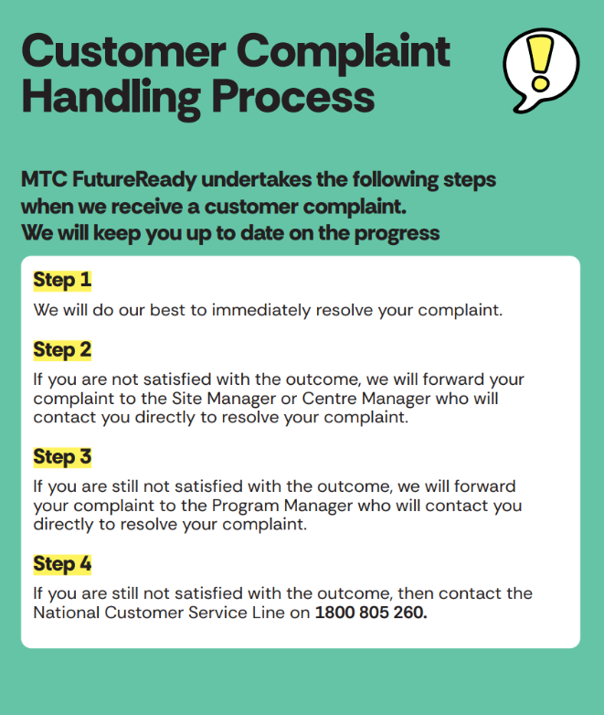

Remember, it is against the law for anyone to victimise you for making a complaint.

If you are satisfied with the result at any stage of the process, the complaint will end, and you do not have to do anything else.

If you are not satisfied with the MTC complaint process you may refer your matter to the following external agencies:
- In relation to consumer related issues, the person may refer their complaint to the NSW Office of Fair Trading,.
- In relation to the delivery of training and assessment services, the person may refer their complaint to the National Training Complaints Service via the following phone number: 13 38 73 or visit the website at https://www.dewr.gov.au/national-training-complaints-hotline .
- In relation to complaints about the RTO and have gone through the appeals process, students can refer a complaint the regulator, ASQA; https://www.asqa.gov.au/about/complaints/complaints-about-training-providers
- In relation to matters relating to privacy, the person may refer their complaint to the Office of the Australian Information Commissioner via the website; https://www.oaic.gov.au/privacy/privacy-complaints
- In relation to matters relating to discrimination, the person may refer their complaint to the Anti-discrimination board of NSW; https://antidiscrimination.nsw.gov.au/

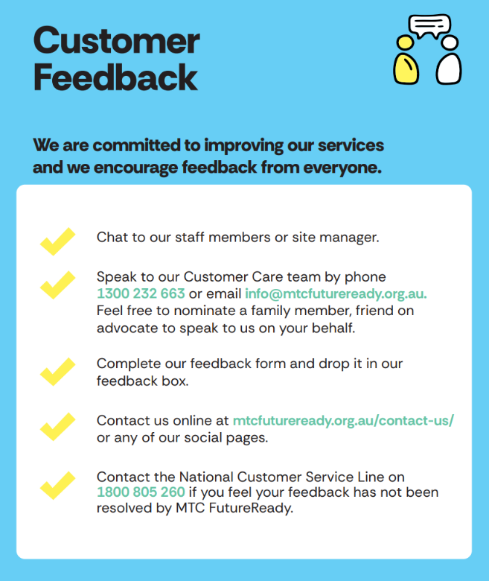

Additional Support Services
If you are having any personal problems and need support, please see below for a list of free or low-cost counselling and support services.
Al-Anon
Self-help organisation for family and friends of people with alcohol problems.
Phone: (03) 9620 2166 (Monday–Thursday), website: http://www.al- anon.org/australia/
Alcohol and Drug Information Service (ADIS)
24-hour confidential telephone counselling service
Phone: (02) 9361 8000 or toll free 1800 422 599
Drug and Alcohol Specialist Advisory Service (DASAS)
Service available in NSW 24 hours a day and 7 days a week
Phone: 9361 8006 (Sydney) and toll free 1800 023 687 (regional and rural callers)
Family Drug Support Helpline
Service available 24 hours
Phone: 1300 368 186, website: www.fds.org.au
Gay and Lesbian Counselling Service of NSW
Phone: Sydney Area: (02) 8594 9595, Regional: 1800 18 GLCS, website: Gay & Lesbian Counselling Service of N.S.W. - The Gender Centre INC

Kids Helpline
Counselling service for people under 18 year of age, available 24 hours a day, 7 days a week.
Phone: 1800 551 800, website: http://www.kidshelp.com.au/
Legal Aid NSW
Legal advice over the phone or face-to-face at a Legal Aid Office located throughout Sydney
Phone: 1300 888 529, website: http://www.legalaid.nsw.gov.au

Lifeline
Crisis line available 24 hours
Phone: 13 11 14, website: http://www.lifeline.org.au/
Relationship Help Online (Relationships Australia)
Website: Relationship Support | Relationships Australia
Sydney Sexual Health Centre
Address: Level 3, Nightingale Wing, Sydney Hospital, 8 Macquarie St, Sydney NSW 2000 Phone: 61 2 9382 7440, website: http://www.sshc.org.au/
Telephone Interpretation Service National (TIS)
Telephone interpretation service available in over 170 different languages and dialects 24 hours a day, 7 days a week. Phone: 131 450; website: Translating and Interpreting Service (TIS National)

Further Information
Further information is obtainable by contacting our offices. One of our representatives will be happy to help you with any enquiries you may have or assistance you may need. Our contact details are as follows:
Address MTC FutureReady (Head Office)
Phone Number Level 1, 334-336 Illawarra Road,
Marrickville, NSW 2204

www.mtcfutureready.org.au
RTO Code 90171

